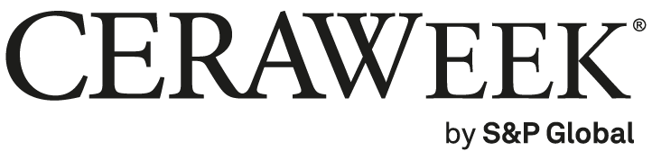

Thank you for your interest in CERAWeek 2025 being conducted March 10-14, 2025, in Houston, TX. CERAWeek is able to provide a visa invitation letter to any confirmed, paid registrant requesting one. Please note, your CERAWeek 2025 registration must be finalized prior to a visa support letter being provided. The full list of requirements necessary to receive a support letter can be found here.

Please complete the grid below and include information regarding the US embassy* to which the letter should be addressed. Failure to provide requested information will result in a delay of the production of the visa invitation letter.

Email completed details to tammy.nelson@spglobal.com and a visa invitation/support letter will be returned to you shortly thereafter.

Surname Name on passport (last name):
Given Name on passport (first name):
Nationality:
Gender:
Date of birth:
Passport number:
Passport issue date:
Passport expiry date:
Passport place of issue:
Company name:
Job title:
Company address:
Company phone number:
Arrival date to Houston:
Departure date from Houston:
*US Embassy to which the letter should be addressed. Please include city and country of the embassy.

Thank you.

